**Fiber drawing techniques**

During the spring of 2019 we have accomplished around 10 fiber drawing sessions using an optically graded silicon preform. The goal for the diameter of the uncoated fiber was set to 125 um and to 225 um with the DSM acrylate coating applied. Additional expected properties of the final fiber are uniformity, strength, flexibility and relatively low losses. In the following text we will describe important technical aspects and challenges behind a typical fiber drawing session.

**Furnace**

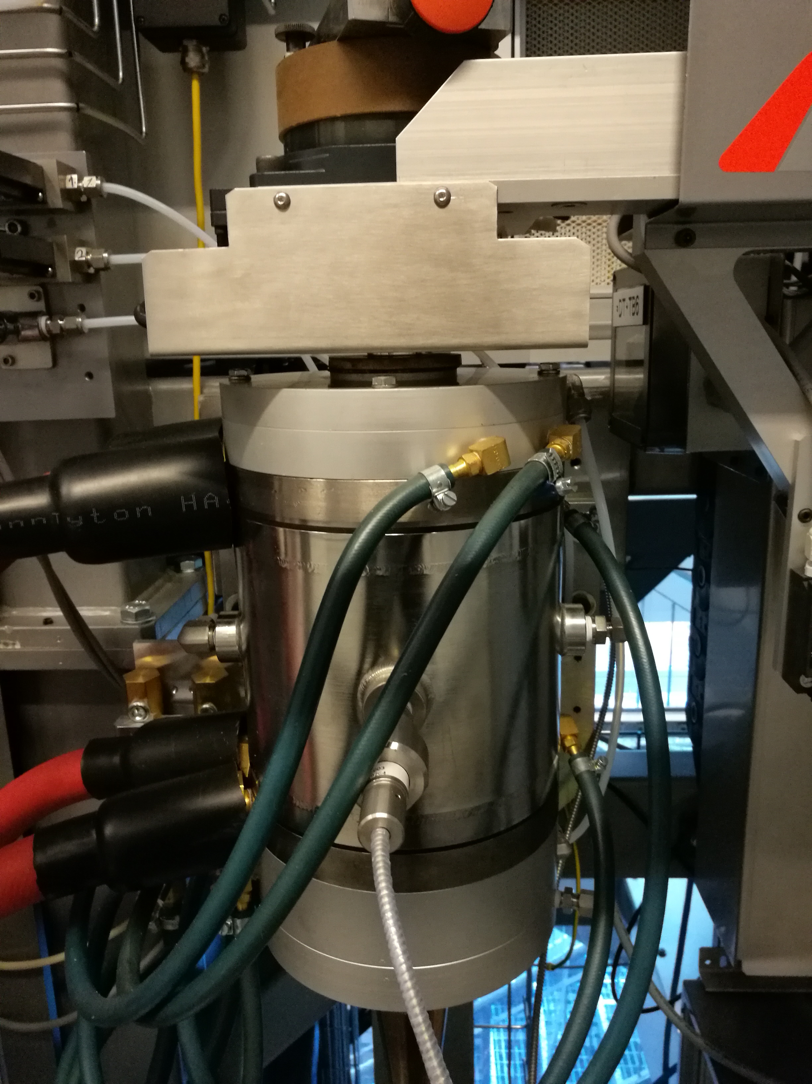During the start-up phase of the fiber drawing sessions we encountered several challenges that needed to be addressed before we could continue. The first challenge was how to successfully fire up the graphite furnace when the heating button is engaged from the control panel, see picture to the right. Before the heating is able to start, flow of cold water and flow of argon gas must be initiated manually. Then the heating should start immediately after the heating button is pressed, ideally, but this was rarely the case since the surface contact between the graphite heating element and the terminals is simply too week. The solution was to use a short screwdriver in order to press the graphite element from the top of the furnace towards the electrical conductor at the bottom of the furnace in order to increase the surface contact area between the two materials. If the surface contact increases enough then the voltage across the poles of the graphite element will start to drop indicating that the electrical current is being converted to heat in the graphite element and thereby the furnace is engaged in the heating mode. In approximately 3 minutes the temperature of the furnace will rise to 2000 C. If the fiber is present we can start pulling it using the start-up capstan and a speed of 5 meters/min. If there is no fiber present, we need to wait for the first drop as explained in the following text.

**Start-up capstan**

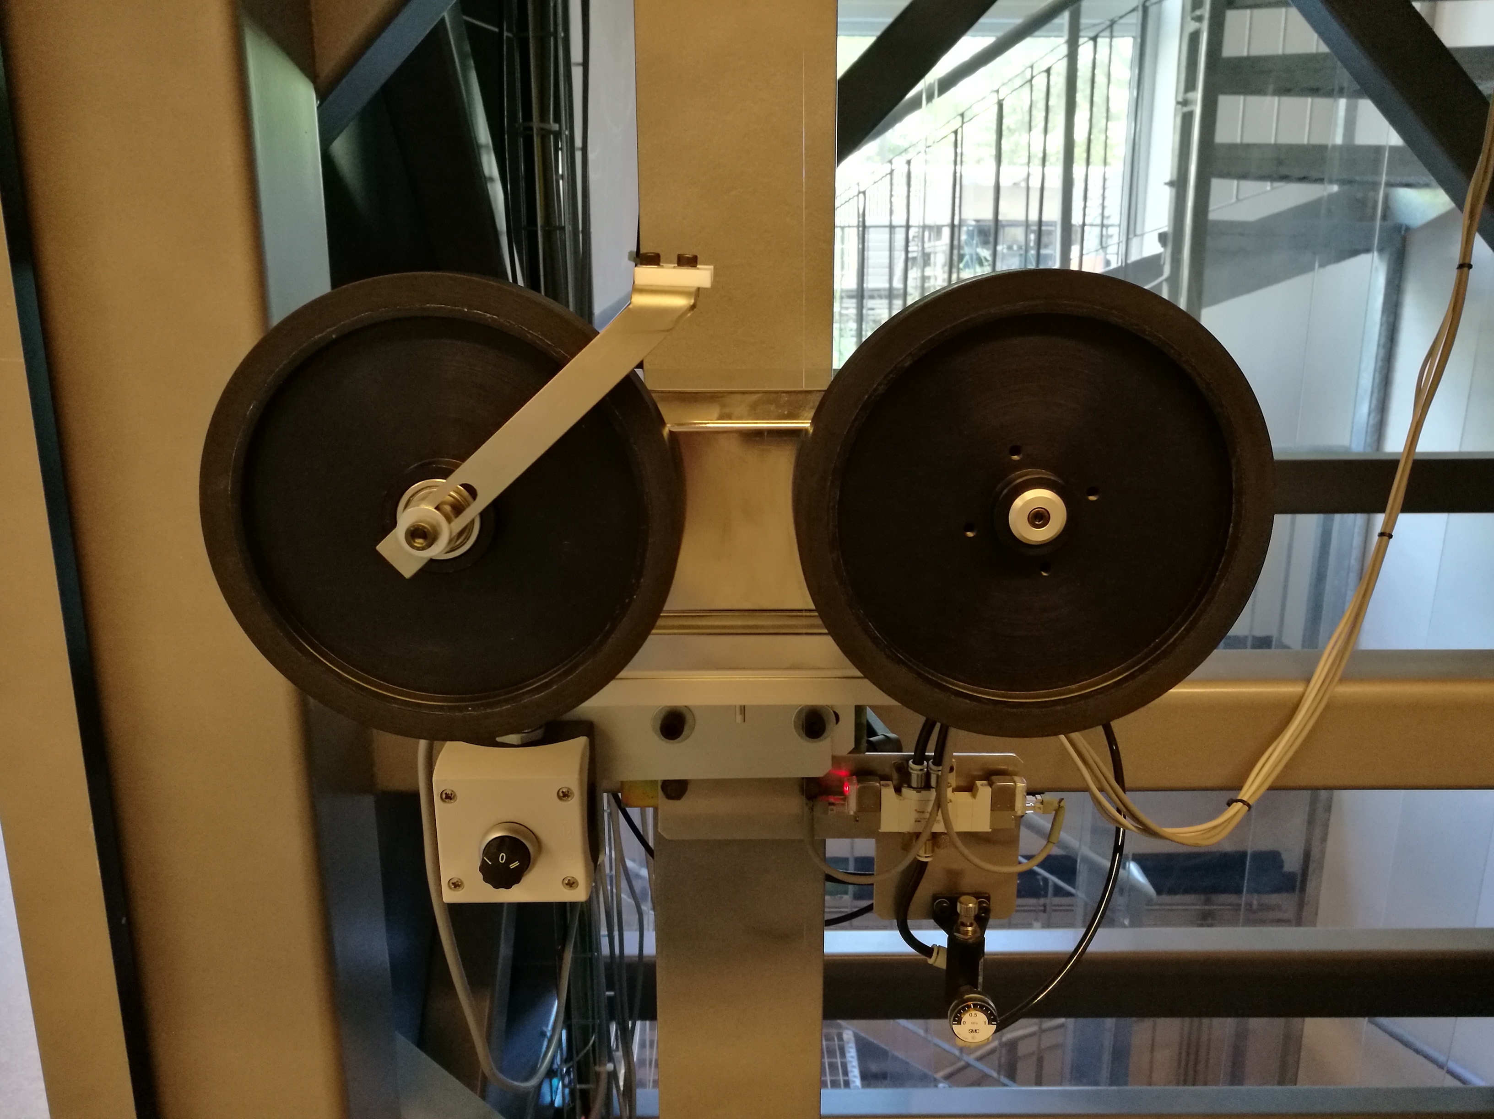After the furnace start up we usually need to wait for the first drop in which case the bottom waist of the perform of approximately 5 mm should be placed in the middle of the furnace. The first drop of the preform material takes usually 12 to 15 minutes before it starts to descend towards the start-up capstan, see picture to the right. The drop is captured using a metallic bucket and the fiber is cut just below the capstan wheels. Then the fiber is guided carefully in place between the two capstan wheels and wheels are locked into the drawing position by turning the small round black turn-button below the capstan. Now, the fiber will be drawn with a constant speed of approximately 6 meters/min. The start-up capstan drawing speed is adjustable and is set in the parameters menu in the control computer using the touchscreen panel, see the picture in the next paragraph. Drawing speeds higher than 6 meters/min pull the fiber at such a rate that manual removal of the accumulated fiber becomes difficult. After the start-up capstan is engaged we quickly move to the bottom floor of the fiber tower in order to remove the accumulating fiber that is continuously pulled by the start-up capstan.

**Drawing and removing fiber in the start-up phase**

In order to remove the surplus fiber that is accumulating on the bottom floor of the fiber tower we use a powerful vacuum cleaner by Electrolux. However, if the fiber has a diameter larger than 175 um the vacuum cleaner might not be very efficient and therefore this part of the fiber should be gathered manually with hands and placed into a designated glass container. When the fiber diameter approaches 175 um we engage the vacuum cleaner in order to remove all the surplus fiber drawn by the start-up capstan. The start-up phase of the fiber drawing sessions takes usually 15 to 20 minutes since, firstly, the diameter of the fiber need to be no larger than 150 um before we can fit it through the coating unit and, secondly, the fiber is very fragile and breakable right after the start-up capstan is engaged. At least 10 minutes of continuous fiber drawing using the start-up capstan is necessary before the fiber gets stronger and more manageable to fit through the coating unit. Notice, during the start-up phase of the drawing session the fiber might break on its way towards the vacuum cleaner, which might result in fiber accumulating on the fiber tower metallic frame just below the capstan wheels. Therefore, from time to time we are forced to run back and forth to the first floor where the start-up capstan is located in order to remove the accumulated fiber and in order to guide newly drawn fiber directly to the vacuum cleaner placed on the bottom floor.

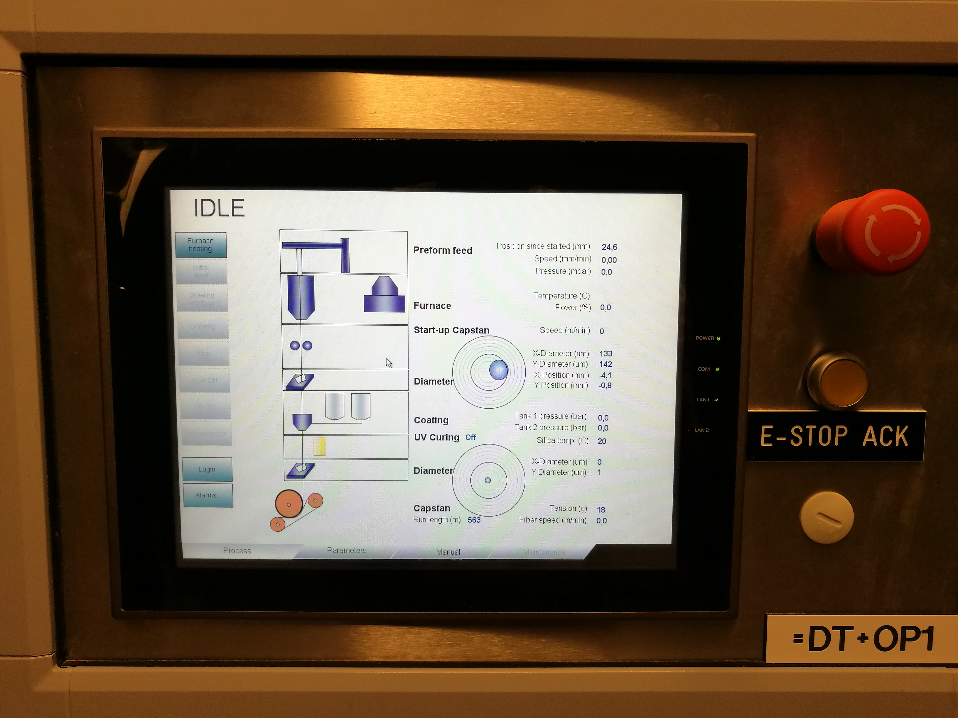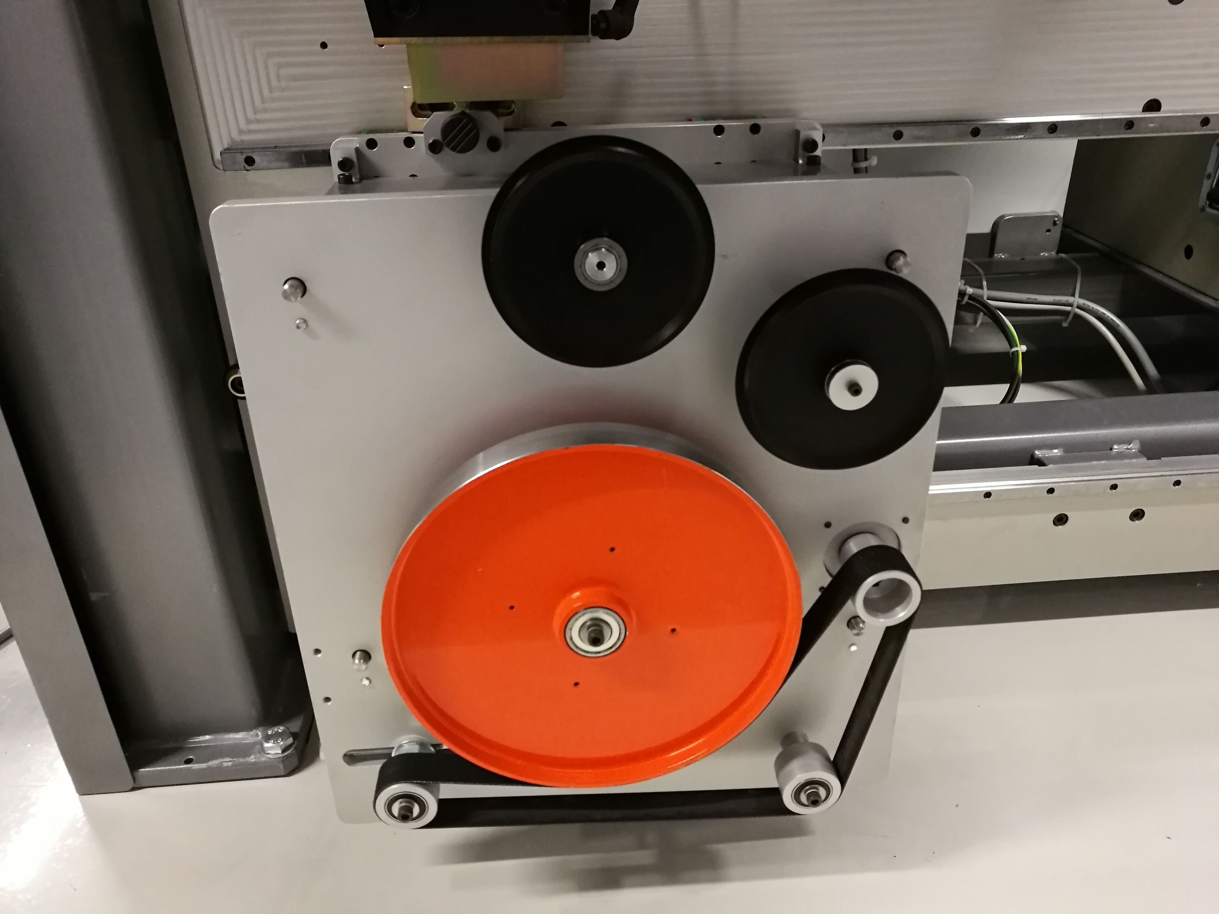One difficulty with the above mentioned start-up phase is the amount of time used to manually dispose of the fiber into a glass container before engaging the vacuum cleaner since fiber diameters less than 175 um can be safely disposed with a vacuum cleaner. Therefore, an alternative method for the fiber drawing in the start-up phase is to use the main capstan instead of the start-up capstan, since the main capstan, see picture to the right,can rapidly reduce the fiber diameter when engaged. We first need to set the goal for fiber diameter, which should be in proximity of 125 um and the main capstan drawing speed, which should be a value no larger than 8 meters/min. The the coating unit should be removed since most probably the initial fiber diameter is too large to fit through the small pinholes placed inside the coating unit. The fiber should be then fitted through the curing unit consisting of a 25 cm long glass pipe, then trough the second fiber diameter measurement unit and finally through the rotating wheels that will lead the fiber to the main capstan. During the first 5 to 10 minutes of the start-up phase the fiber will probably be too fragile for the main capstan to pull the fiber successfully, and in this situation we need to persistently try to get the fiber into the main capstan until the fiber seems strong enough and does not brake. Immediately after we press the button called “DRAWING” on the main control computer, see picture to the right, and the start-up capstan is released while the main capstan is now pulling all the fiber. We then place the vacuum cleaner hose input close to the main capstan in order to remove the accumulated surplus fiber from the floor. Notice that in the “DRAWING” mode the fiber drawing is controlled by an algorithm in the control computer, which means that the current drawing speed might change drastically before it slowly converges towards the goal drawing speed set by the operator. Drawing speeds right after the “DRAWING” button is engaged can be up to 25 meters/min.

**Engaging coating unit and the main capstan**

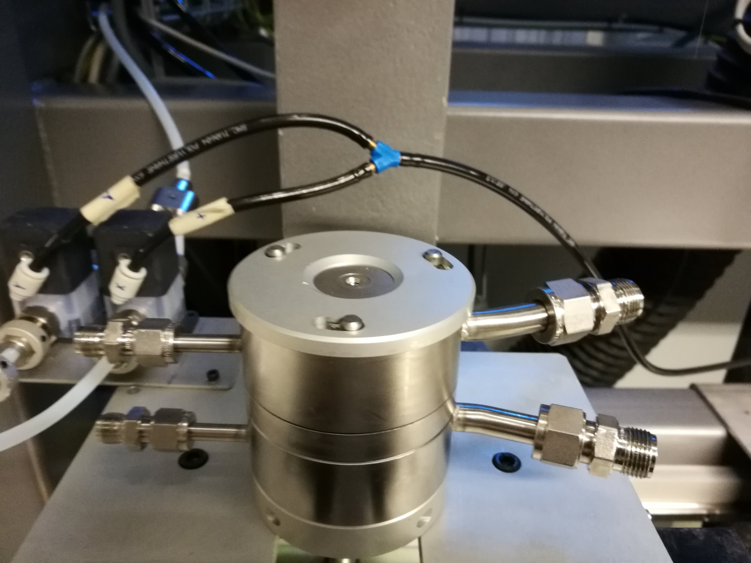When the fiber has stabilized below 150 um we pass the fiber through the 4 pinholes in the coating unit, see picture to the right. The coating unit has 2 stages of the coating, each stage with input and output pinholes. The first stage consist of 175 um input pinhole and 200 um output pinhole, while the second stage consist of 235 um input pinhole and 275 um output pinhole. On the picture to the right the fiber entrance pinhole with 175 um diameter is visible. A typical fiber that we produce with our fiber tower has 125 um in the diameter and 225 um including the coating. Before fitting the fiber through the pinholes we need to be sure that the fiber diameter has stabilized to a value that is at least 20% smaller than the smallest pinhole present in the coating unit. Therefore, patience and observatory work is required in the start-up phase.

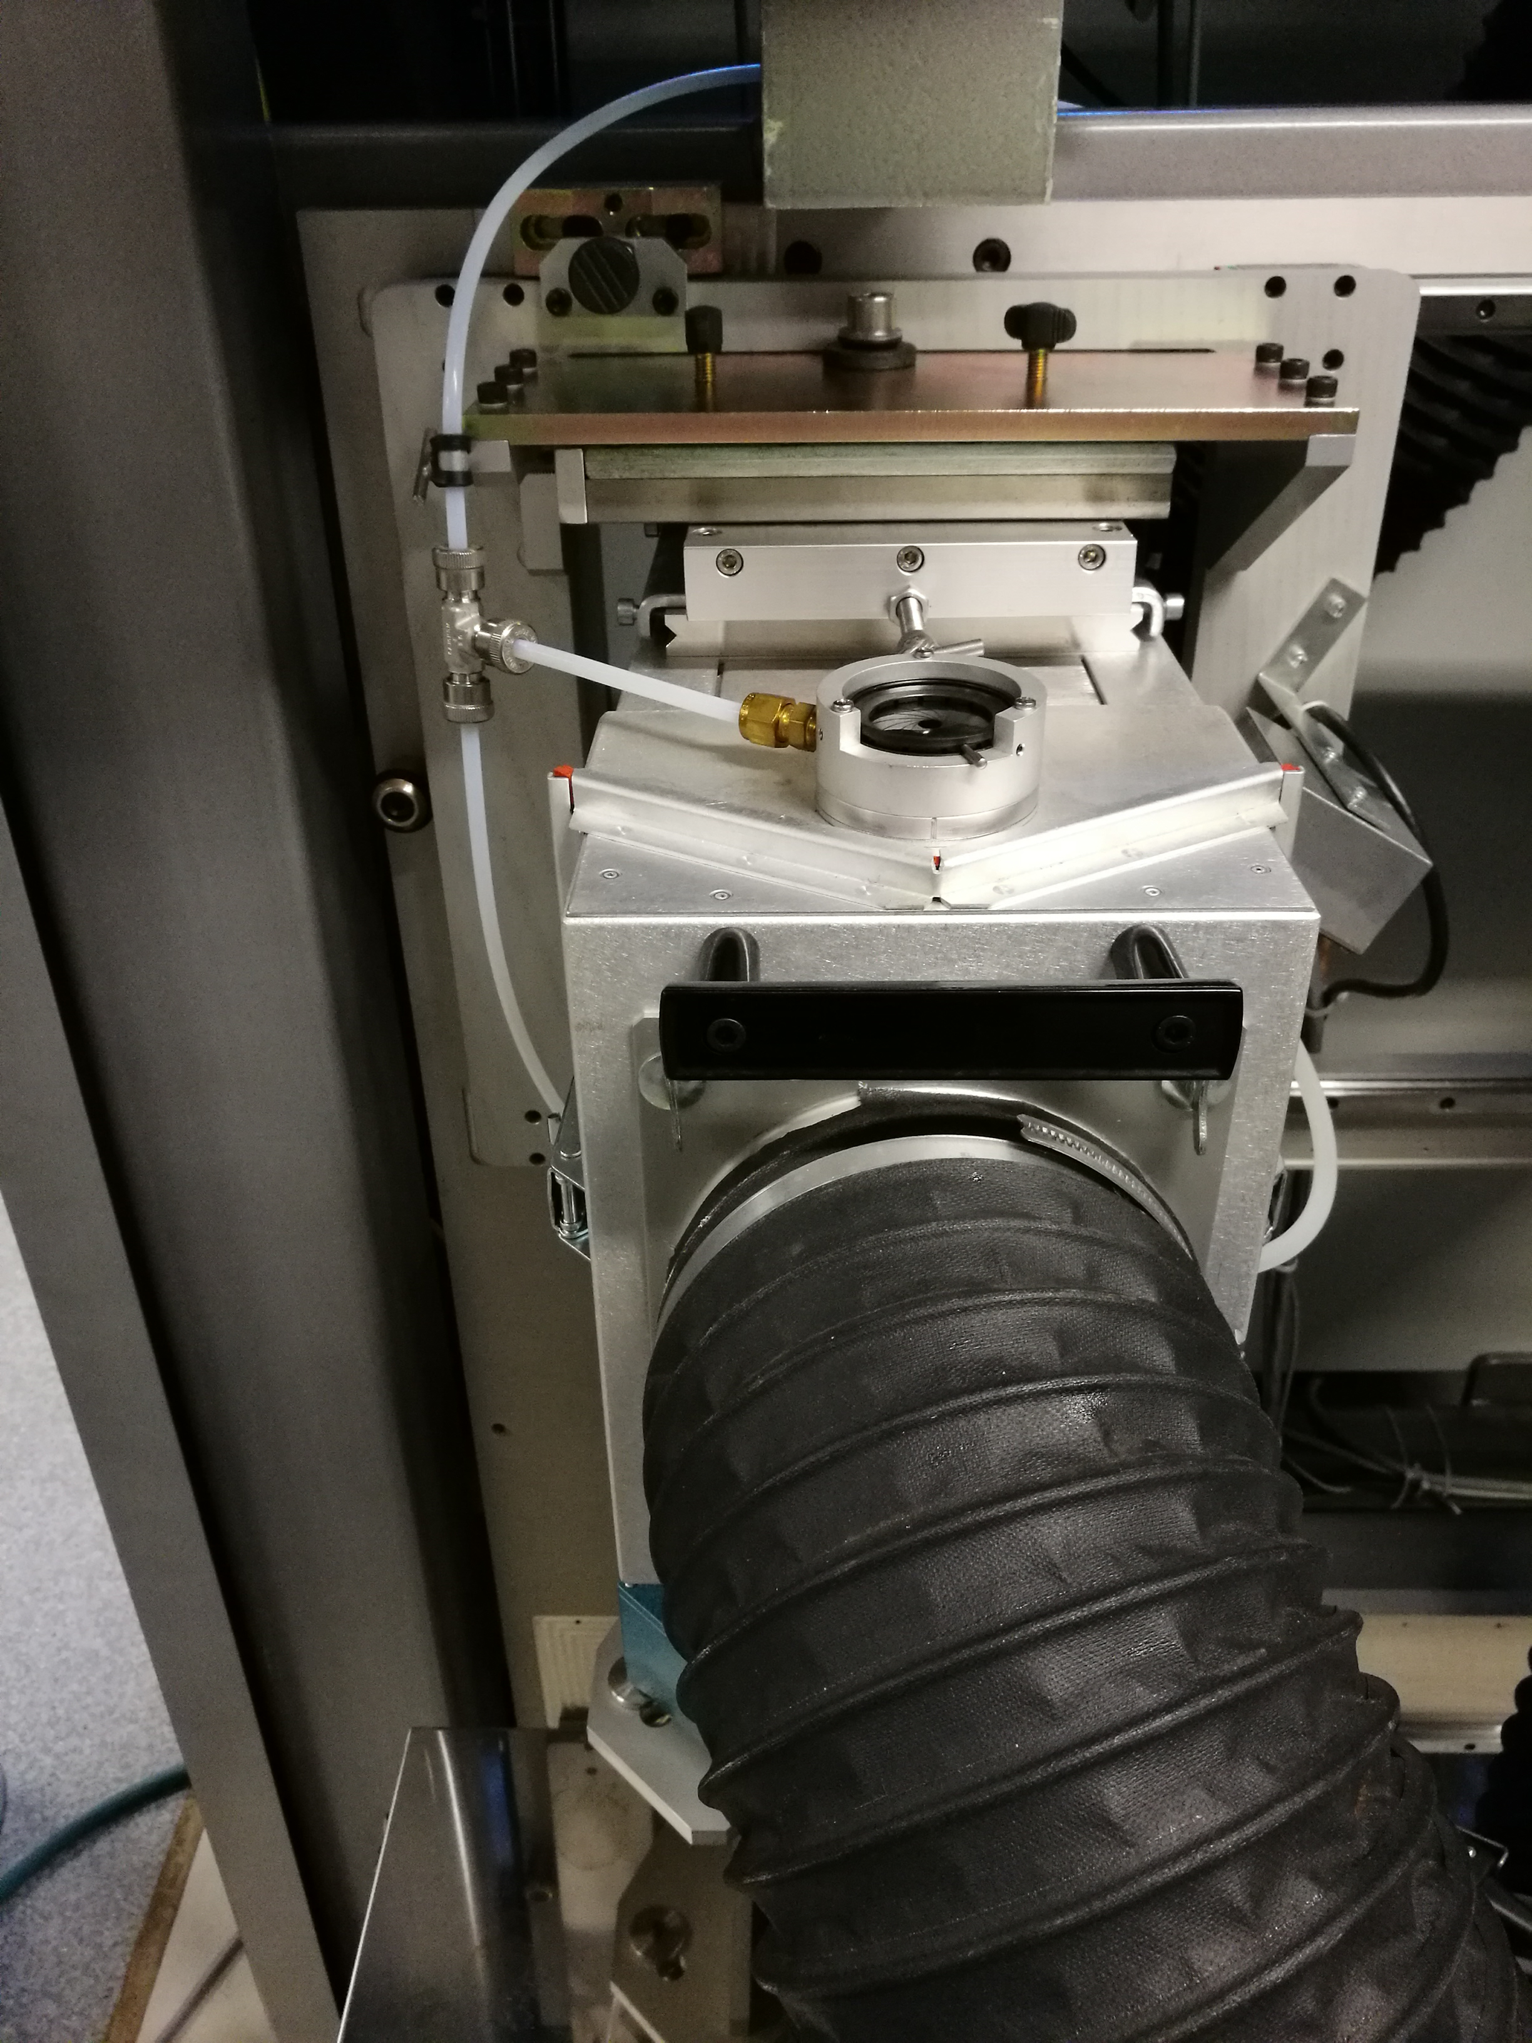When the fiber if fitted through the coating unit we the attach a small weight to the end of the fiber and use gravity in order to pull the fiber through the narrow glass pipe in the curing unit, see the picture to the right, then we pull the fiber through the second second fiber diameter measurement unit and finally we engage the main capstan. The big black hose shown in the picture is a part of the cooling system necessary to remove hot air from the UV lamp box. Next we quickly press the button “DRAWING” on the touchscreen of the main control computer, so that the start-up capstan and main capstan are not simultaneously engaged. In the drawing mode the start-up capstan will be disengaged and all the pulling is now done by the main capstan. Remember to place the small round black turn-button below the capstan wheels in the zero position, then the main computer on the bottom level has the control of the start-up capstan.

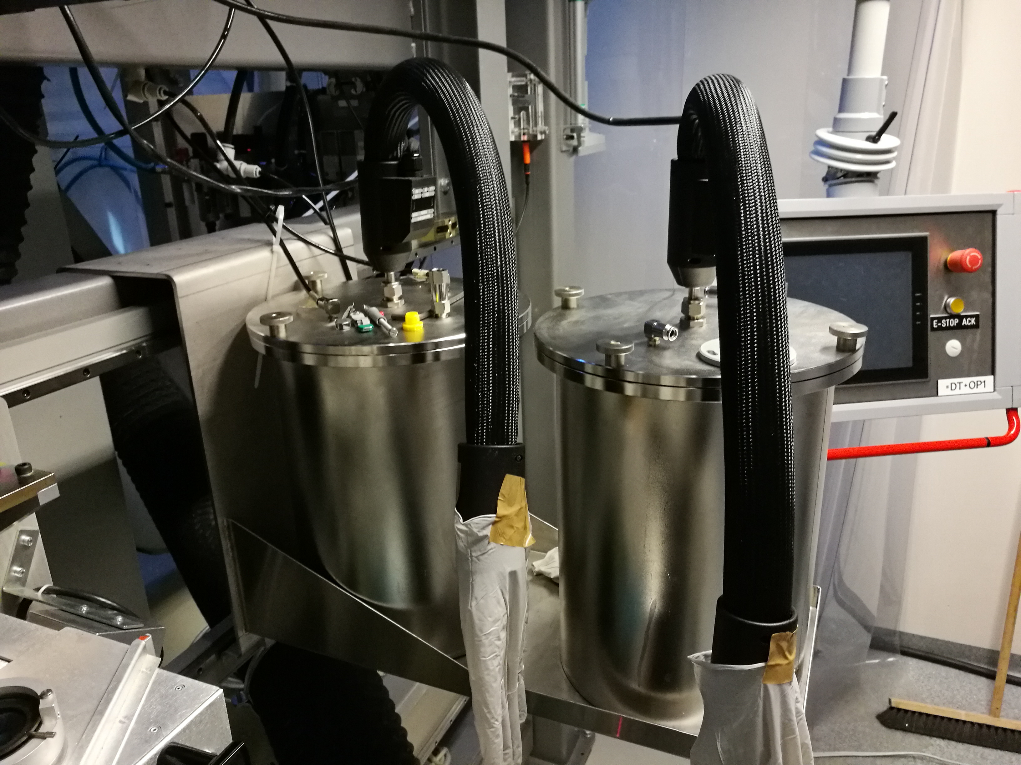When the fiber is pulled smoothly through the coating unit we pressurize one of the two coating containers, see the picture to the right, to 4.2 bar by pressing the button “ACR ON” on the main control unit. The curing UV lamp will start automatically on half-power and soon after acrylate will be applied on the surface of the fiber. The reason why we only engage one caoting container and not both is because most fiber types require only single coating layer. The caoted fiber is now ready to be collected using a fiber roller and the take-up unit. The take-up unit is connected to the main control unit and thereby the fiber roller speed is automatically adjusted to the speed of the main capstan.

**Challenges during fiber drawing sessions**

As mentioned earlier the furnace in fiber tower is based on resistive heating of a pipe-shaped graphite element where very large currents at a DC voltage are sent trough the terminals. The problem is that the surface contact between the graphite heating element and the terminals is too week for a proper contact so external pressure must be applied in order to get current flowing through the graphite element. At the moment this is done manually with a small tool, such as an hex key or a screwdriver, pressing at the top-end of the graphite element until the graphite starts to conduct current (DC voltage drops). This procedure is not safe and will be addressed in the foreseeable future. Besides the furnace start up challenge the rest of the fiber tower apparatus functions as according to the specifications given by Optogear.

The procedure of pulling the fiber through the coating unit and subsequently through the glass pipe in the curing unit can often be challenging. If the fiber is too fragile, which is normal in the initial phase of the fiber drawing, then the fiber can brake inside the coating unit if we pull too quickly. Another challenge are acrylate residues sitting on the surface of the glass pipe due to previous coating sessions. The acrylate can be so sticky that the fiber gets attached to it and breaks in the process of guiding the fiber towards the main capstan. However, once the main capstan is engaged the fiber has steady position inside the glass pipe and the risk of breaking the fiber during the automatized pulling is unlikely.

The coated fiber seems wet and sticky after it has been illuminated by the UV light in the curing unit. The fiber can be so sticky that it gets attached on the main capstan wheel while it is in rotation. The operator has a chance to save the fiber from breaking if the capstan speed is relatively low for instance 8 meters/min. At higher speeds there are no ways to safely remove the attached fiber from the main capstan and the entire fiber drawing process has to be terminated in order to clean the main capstan wheel. The cleaning is most efficiently done using small amount of isopropanol on a piece of white polyester cleanroom wiper.

**Achievements during fiber drawing sessions**

We have tested and proved that all general functionalists of the fiber tower apparatus work as expected. We have furthermore successfully drawn couple of kilometers of fiber with a fixed diameter and similarly we have drawn hundreds of meters of fiber with the acrylate coating applied. During the drawing sessions our confidence with the functionality of the fiber tower has increased significantly and we have gained a lot of knowledge concerning minor practical issues with melted glass that might have a large impact on general quality of the finished fiber.